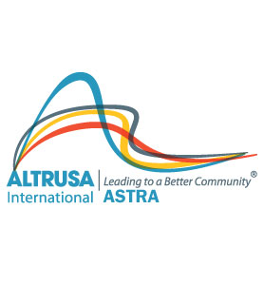

ASTRA MEMBERSHIP APPLICATION

Name_____________________________________________________________

Address__________________________________City______________________

Zip____________ Phone #____________________OK to Text? Y______N_____

E-mail (print clearly) __________________________________T-Shirt Size_______

Birth Date: ____________________ Grade/Level: ________________________

Other Club Affiliations (past or present) _______________________________

__________________________________________________________________

Hobbies/Interests__________________________________________________

__________________________________________________________________

Photo Release: I hereby give Altrusa International, Inc. the absolute right and permission for my images in its promotional materials and publicity efforts. I understand that the photograph(s) may be used in publication, print ad, electronic media or other forms of promotion. I acknowledge Altrusa’s right to crop or treat the photograph in its discretion. I waive any right to compensation arising from or related to the use of the photograph. I acknowledge that Altrusa owns the photograph.

The signature of the individual on this form indicates approval for the use of ASTRA related photographs as indicated above.

______I DO NOT give photo release permission.

Signature of Applicant ______________________________ Date____________

- - - - - - - - - - - - - - - - - - - - - - - - - - - - - - - - - - - - - - - - - - - - - - - - - - - - - - - - - - - - - - - - - -

Application Approved_____________________ (Altrusa Advisor) Date__________

