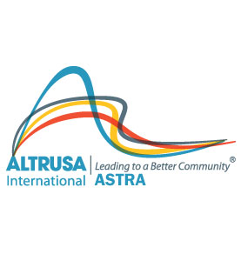

PARENT/PHOTO PERMISSION FORM
ASTRA CLUB of LOPEZ HIGH SCHOOL

My minor child________________________________ has my permission to participate in the ASTRA Club of ___________________ to include any meetings, fundraisers and various functions.

I realize that some activities will require my child to leave school property and I give my child permission to leave school property for the purpose to serve, work on projects, or whatever other means is required to complete an ASTRA community service project.

When transportation cannot be provided by me (parent/guardian) I also consent to my child being transported by vehicle to and from projects, functions and fundraisers by the advisors of the ASTRA Club who also may be members of Altrusa International of ________________________.

In case of emergency I can be reached at: (please PRINT)

Parent’s/Guardian’s Name: _________________________________________________________

Address: _______________________________________________________________________

Phone #_______________________ Relationship to minor child ___________________________

Any health conditions or allergies advisors need to be aware of are: _________________________

________________________________________________________________________________

Physician’s Name: _________________________________ Phone #: _______________________

______________________________________________ __________________________
Signature of Parent/Guardian: Date

I hereby give Altrusa International, Inc. the absolute right and permission to use photos of my minor child named on this form, in its promotional materials and publicity efforts. I understand that the photograph(s) may be used in a publication, print ad, media, (e.g. video, CD-ROM, internet, World Wide Web), or other forms of promotion. I acknowledge that Altrusa owns the photograph. I acknowledge Altrusa’s right to crop or treat the photograph in its discretion. I also acknowledge that Altrusa may choose not to use the photograph at this time, but may do so at its own discretion at a later date. I waive any right to compensation arising from or related to the use of the photographs.

______________________________________________ ________________________________
Signature of Parent/Guardian: Date

_______ I do NOT give photo release permission for my minor child.

